



**PROJECT REPORT ON MACHINE LEARNING**

**NAME:HARSHIL MADAAN**

**EMAIL:hmadaan50_be21@thapar.edu**

**ACKNOWLEDGEMENTS:**

I express my deepest thanks to the company for making the concepts easy to understand and implement and for also providing proper guidance and support to complete this project.The summer training opportunity I had with azure skynet was a great chance for learning and professional development. Therefore, I consider myself as a very lucky individual as I was provided with the oppurtunity of trainug

|  |  |  |
| --- | --- | --- |
| **S.NO** | **CONTENTS** | **PAGE NUMBER** |
| 1 | INTRODUCTION | 1 |
| 2 | STEPS PERFORMED TO DEVELOP THE PROJECT | 2-5 |
| 3 | PROJECT OUTPUT | 6 |
| 4 | FINAL CODE | 6 |
| 5 | CONCLUSION | 7 |
| 6 | REFERENCES AND BIBLIOGRAPHY | 8 |

**PROJECT NAME: FACE DETECTION**

**AIM:** Detecting faces in the image using OpenCV

**INTRODUCTION**:

Face recognition is the technique in which the identity of a human being can be identified using ones individual face. Such kind of systems can be used in photos, videos, or in real time machines. The objective of this article is to provide a simpler and easy method in machine technology. With the help of such a technology one can easily detect the face by the help of dataset in similar matching appearance of a person. The method in which with the help of python and OpenCV in deep learning is the most efficient way to detect the face of the person. This method is useful in many fields such as the military, for security, schools, colleges and universities, airlines, banking, online web applications, gaming etc. this system uses powerful python algorithm through which the detection and recognition of face is very easy and efficient.

**STEPS :**

**STEP 1:**

Installation of OpenCV

**OpenCV:** OpenCV is a cross-platform library using which we can develop real-time **computer vision applications**. It mainly focuses on image processing, video capture and analysis including features like face detection and object detection.

**Installation of OpenCV:**

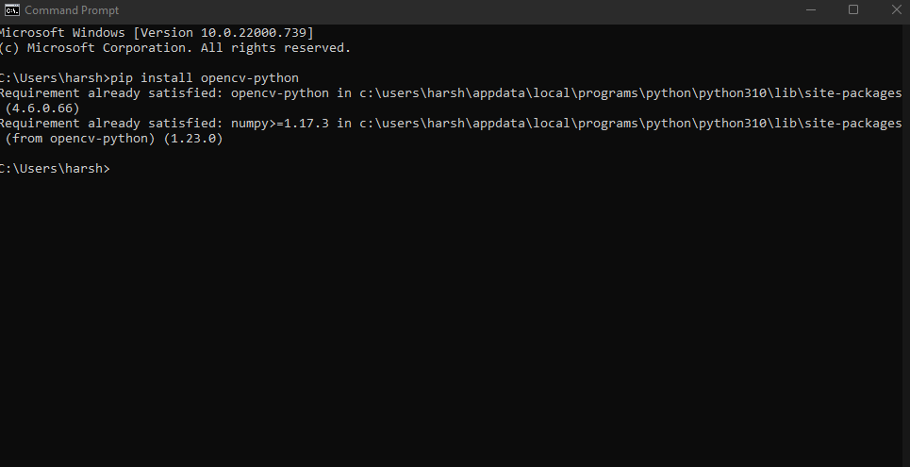

**STEP 2:**

Check if the OpenCV is installed successfully

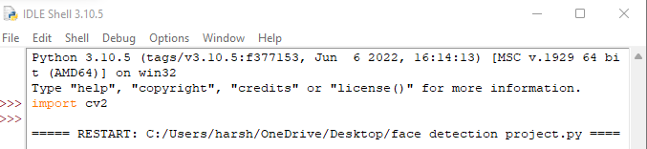

If this command does not show an error that means the OpenCV is installed successfully.

**STEP 3:**

To turn on the camera not manually but through a program

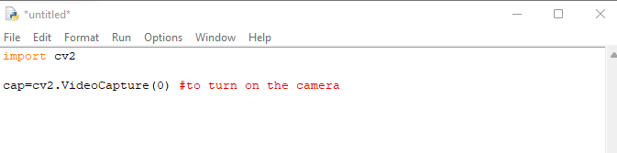

**STEP 4**

To read and display images

CODE:

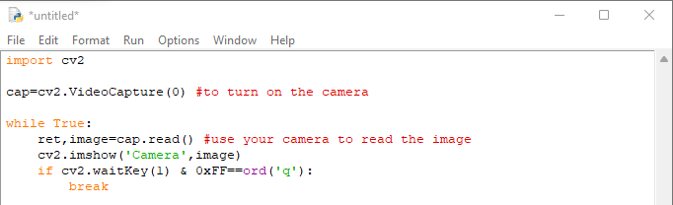

OUTPUT(next page)

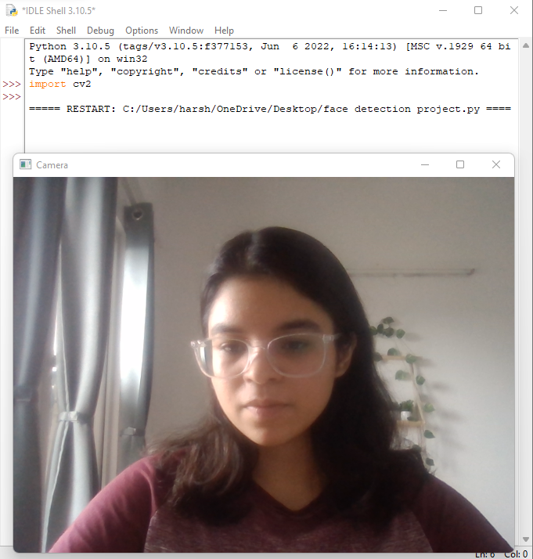

**STEP 5**

To close all the windows press ‘q’

**STEP 6**

Gathering the data:

(.xml format file)(haar-cascade file)

What is a haar-cascade file?

A Haar wavelet is a mathematical fiction that produces square-shaped waves with a beginning and an end and used to create box shaped patterns to recognize signals with sudden transformations. By combining several wavelets, a cascade can be created that can identify edges, lines and circles with different colour intensities. These sets are used in Viola Jones face detection technique in 2001 and since then more patterns are introduced for object detection. To analyse an image using Haar cascades, a scale is selected smaller than the target image. It is then placed on the image, and the average of the values of pixels in each section is taken. If the difference between two values pass a given threshold, it is considered a match. Face detection on a human face is performed by matching a combination of different Haar-like-features. For example, forehead, eyebrows and eyes contrast as well as the nose with eyes as shown below in figure A single classifier is not accurate

enough. Several classifiers are combined as to provide an accurate face detection system.

CODE:

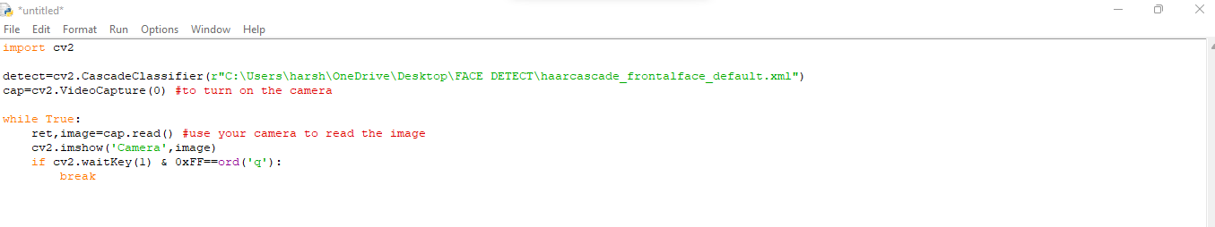

**STEP 7**

to convert the image to black and white colour. Here, gray is the input grayscale image

CODE:

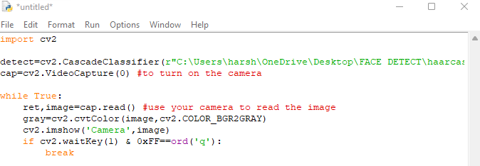

**STEP 8**

Create a box around the image

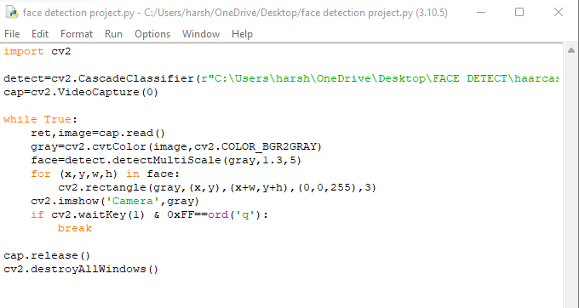

**PROJECT OUTPUT:**

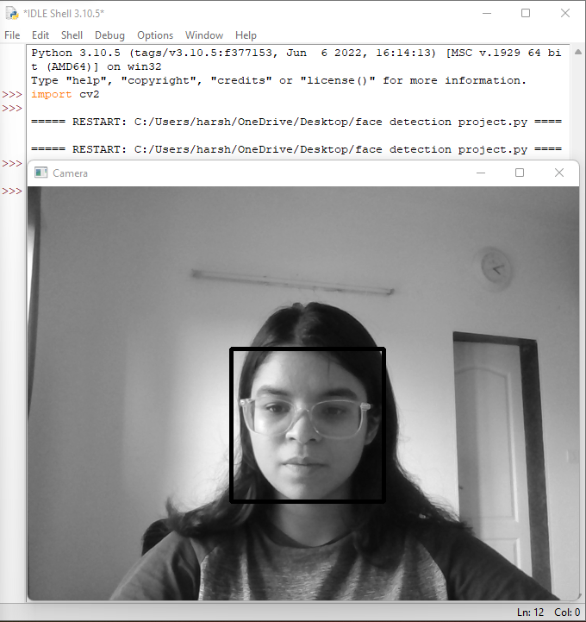

**COMPLETE CODE:**



**CONCLUSION:**

Face recognition systems are currently associated with many top technological companies and industries making the work of face recognition easier. The use of python programming and OpenCV makes it an easier and handy tool or system which can be made by anyone according to their requirement. The proposed system discussed in this project will be helpful for many as it is user friendly and cost efficient system. Hence by the use of python and OpenCV the face recognition system can be designed for various purposes.

REFERENCES:

1. <https://azureskynet.in/courses/machine-learning/>
2. www.python.org

BIBLIOGRAPHY:

1. tutorialspoint.com
2. Irjet.net
3. Mygreatlearning.com
4. Researchgate.net